**Technology Stack**

**Frontend:**

* **React.js** – For building the user interface.
* **Redux** – For state management.
* **HTML, CSS, JavaScript** – Core web technologies.
* **Tailwind CSS** – For styling and UI components.
* **Axios** – For API requests.
* **React Router** – For handling navigation.

**Backend:**

* **Node.js** – Server-side JavaScript runtime.
* **Express.js** – Web framework for Node.js.
* **REST API** – For handling data communication.

**Third-Party Services:**

* **TMDB API** – For fetching movie data.

**Deployment Diagram**

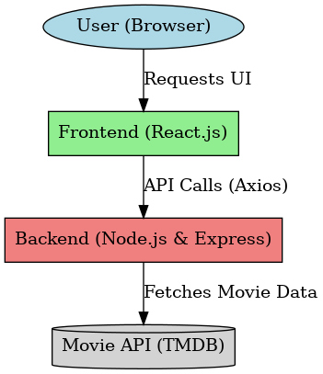

**Component Diagram**

